Discussion of Algorithms
Driver program calls routeCalc.calculateRoute()

routeCalc.calculateRoute()
- Craetes a new route from origin to destination
- Adds the new route to ArrayList<Route>routeList
- While all routes are not yet complete (i.e. routes having status='open' exist in ArrayList<Route>routeList), do the following
3.a. updateRoute (index of the route to be updated) //This function keeps calling route.updateRoute(), until route's status=='close' or route's status='dead'
3.a.a.. If currentRteStatus==”open” && finalDestReached==”false”, then
3.a.b.. updateRoute() gets all outgoing roads from legOrigin
3.a.c.. If number of out going roads from legOrigin == 0, then currentRte=”dead”. If number of outgoing roads > 0, then below is executed
3.a.d. Verifies if outgoing roads have already been covered or not
3.a.f. If all outgoing roads have been covered, route status = “dead”. If there are roads, which have not yet been covered, below is executed
3.a.f.a. Takes the first road and include it in current route.
3.a.f.b Remove the road from the list
3.a.f.c. Calls duplicateRoute (Listof outgoing roads, not yet been covered)
3.a.f.c.a. For each road in the list, duplicateRouet()
3.a.f.c.b. creates a new route (origin, legOrigin, finalDest,routeList)
3.a.f.c.c. Adds the road s of existing route to ArrayList<Road> of the new route
3.a.f.c.d Adds new route to routeList

3.a.f.e Checks if road being added to current route has already been covered or not
3.a.f.f. If road has already been covered, currentRte=”dead”, else road is added to current route
3.a.f.g. legOrigin of current rte = destination of the new road added to the current route

3.b. Updates index, so that next route can be updated
- Calculate shortest route
4.a. .shortestRte=routeList.get(0);
4.b. . While not looped through all elements of routeList
4.b..a. Get next route from routeList (i.e. routeList.get(index))
4.b.c. . If total distance of the route = shortest distance so far, shortestRoute=routeList.get(index)

Town Parameters

Town | Longitude (Deg Min Sec) | Latitude (Deg Min Sec)
Sibu | 111 58 58 | 2 15 51.12
Selangau | 112 27 55 | 2 29 49.79
Mukah | 112 05 37.10 | 2 54 3.32
Oya | 111 52 50.88 | 2 51 35.10
Dalat | 111 56 20.12 | 2 44 35.79
Igan | 111 42 39.24 | 2 49 27
Matu | 111 31 52.31 | 2 40 40.79
Daro | 111 25 32.87 | 2 31 1.12

Effects of Changing Road connections

1. Origin = Sibu; Destination = Selangau

Road Network 1 for origin = Sibu, destination=Selangau
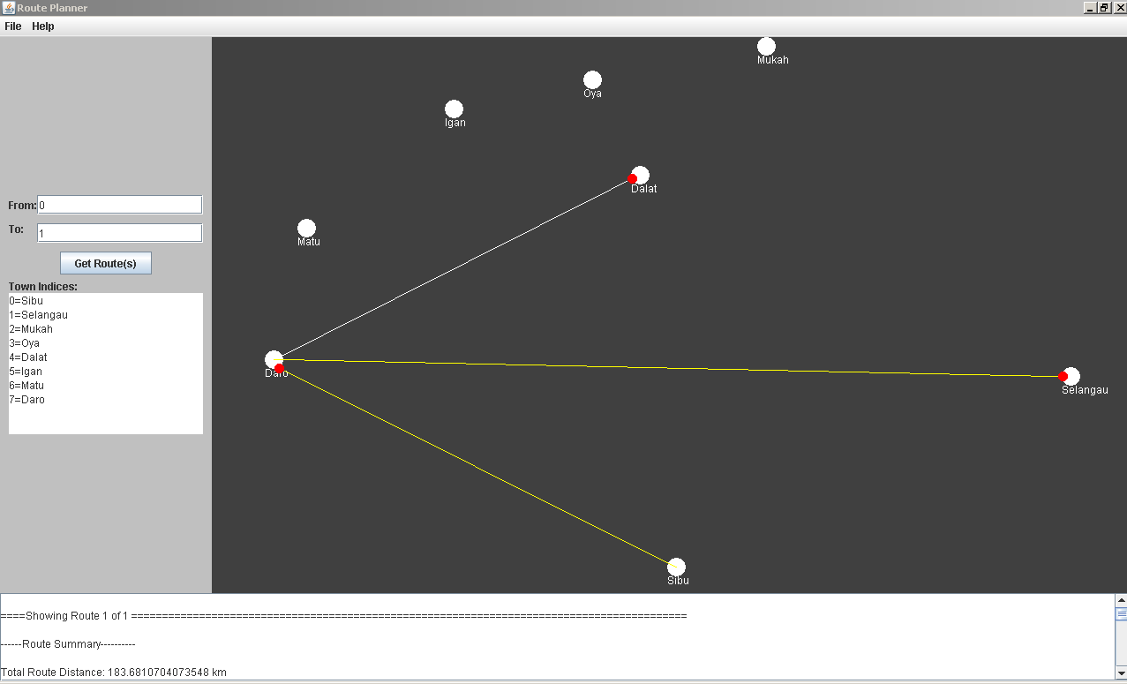
Below is the output

====Showing Route 1 of 1

------Route Summary----------

Total Route Distance: 183.6810704073548 km

Number of Legs: 2

Origin: Sibu

Destination: Selangau

Route Status: close

--------------------------------

------Route Legs----------

Road From: Sibu To: Daro Distance: 68.04614019174636 km

Road From: Daro To: Selangau Distance: 115.63493021560845 km

--------------------------------

====Displaying Shortest Route ======================================

------Route Summary----------

Total Route Distance: 183.6810704073548 km

Number of Legs: 2

Origin: Sibu

Destination: Selangau

Route Status: close

--------------------------------

------Route Legs----------

Road From: Sibu To: Daro Distance: 68.04614019174636 km

Road From: Daro To: Selangau Distance: 115.63493021560845 km

Road Network 2 for origin = Sibu, destination=Selangau
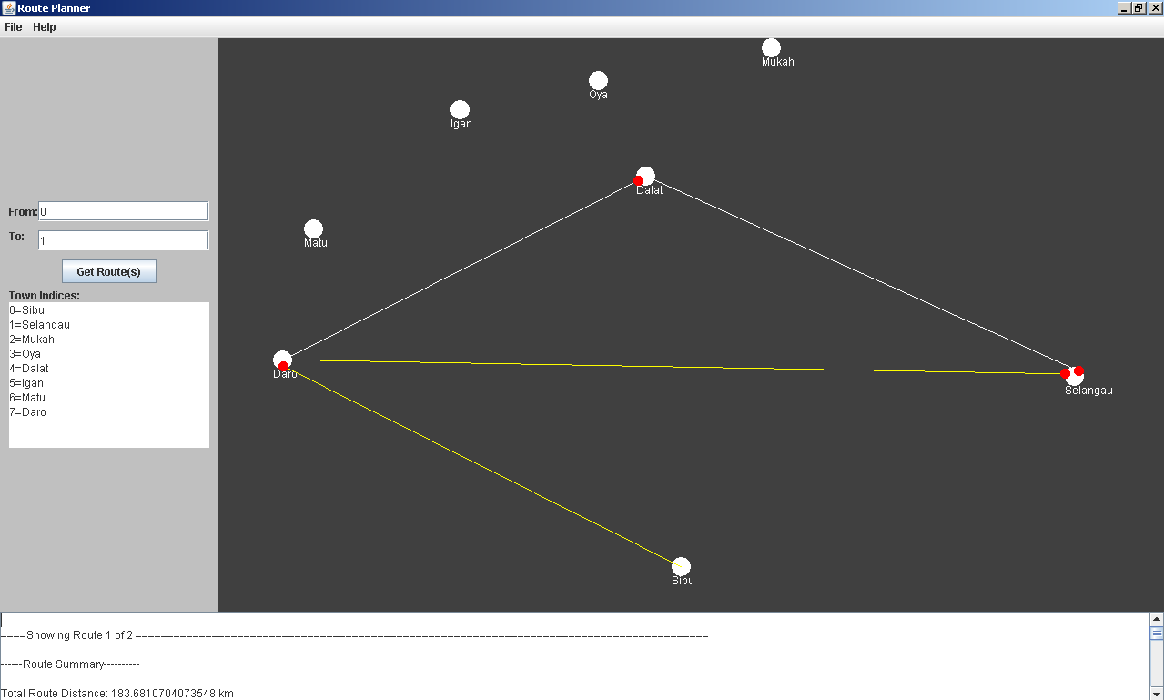
Below is the output

====Showing Route 1 of 2 =====================

------Route Summary----------

Total Route Distance: 183.6810704073548 km

Number of Legs: 2

Origin: Sibu

Destination: Selangau

Route Status: close

--------------------------------

------Route Legs----------

Road From: Sibu To: Daro Distance: 68.04614019174636 km

Road From: Daro To: Selangau Distance: 115.63493021560845 km

--------------------------------
====Showing Route 2 of 2 ==================================

------Route Summary----------

Total Route Distance: 195.0581610818996 km

Number of Legs: 3

Origin: Sibu

Destination: Selangau

Route Status: close

--------------------------------

------Route Legs----------

Road From: Sibu To: Daro Distance: 68.04614019174636 km

Road From: Daro To: Dalat Distance: 62.37948809504732 km

Road From: Dalat To: Selangau Distance: 64.63253279510593 km

--------------------------------
====Displaying Shortest Route ==========================================================================================

------Route Summary----------

Total Route Distance: 183.6810704073548 km

Number of Legs: 2

Origin: Sibu

Destination: Selangau

Route Status: close

--------------------------------

------Route Legs----------

Road From: Sibu To: Daro Distance: 68.04614019174636 km

Road From: Daro To: Selangau Distance: 115.63493021560845 km

Road Network 3 for origin = Sibu, destination=Selangau
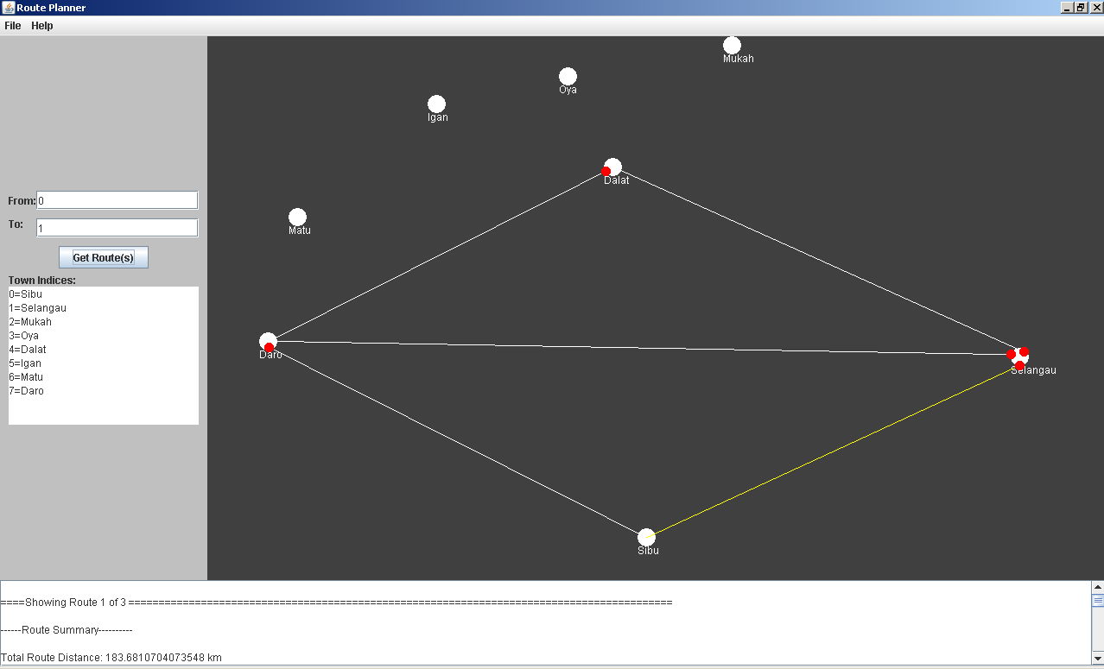
Below is the output

====Showing Route 1 of 3 ===============

------Route Summary----------

Total Route Distance: 183.6810704073548 km

Number of Legs: 2

Origin: Sibu

Destination: Selangau

Route Status: close

--------------------------------

------Route Legs----------

Road From: Sibu To: Daro Distance: 68.04614019174636 km

Road From: Daro To: Selangau Distance: 115.63493021560845 km

--------------------------------

====Showing Route 2 of 3 =====================

------Route Summary----------

Total Route Distance: 59.60813239097836 km

Number of Legs: 1

Origin: Sibu

Destination: Selangau

Route Status: close

--------------------------------

------Route Legs----------

Road From: Sibu To: Selangau Distance: 59.60813239097836 km

--------------------------------

====Showing Route 3 of 3

------Route Summary----------

Total Route Distance: 195.0581610818996 km

Number of Legs: 3

Origin: Sibu

Destination: Selangau

Route Status: close

--------------------------------

------Route Legs----------

Road From: Sibu To: Daro Distance: 68.04614019174636 km

Road From: Daro To: Dalat Distance: 62.37948809504732 km

Road From: Dalat To: Selangau Distance: 64.63253279510593 km

--------------------------------

====Displaying Shortest Route =====

------Route Summary----------

Total Route Distance: 59.60813239097836 km

Number of Legs: 1

Origin: Sibu

Destination: Selangau

Route Status: close

--------------------------------

------Route Legs----------

Road From: Sibu To: Selangau Distance: 59.60813239097836 km

--------------------------------

Comparison of 3 different road networks between Sibu and Selangau

Road Network 1: Output correctly reflects just one possible route between Sibu and Selangau

Road Network 2: Output correctly reflects the change from Road Network 1. Two possible routes are displayed between Sibu and Selangau. And shortest route (183 lm long) is correctly identified out of the two

Road Network 3: Output correctly reflects the change from Road Network 1 and 2. Three possible routes are displayed between Sibu and Selangau. And the direct connection between Sibu and Selangau (59 km long) is correctly identified as shortest route. The shortest route is also highlighted

2. Origin = Daro; Destination = Igan
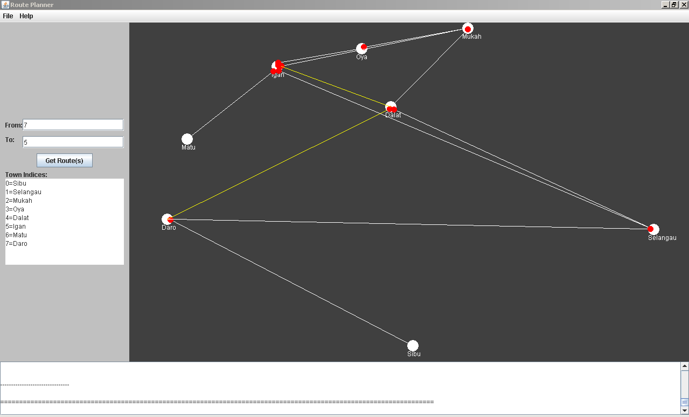
Below is the output
====Showing Route 1 of 7
------Route Summary----------

Total Route Distance: 89.28687671727374 km

Number of Legs: 2

Origin: Daro

Destination: Igan

Route Status: close

--------------------------------

------Route Legs----------

Road From: Daro To: Dalat Distance: 62.37948809504732 km

Road From: Dalat To: Igan Distance: 26.907388622226414 km

--------------------------------

====================================================================================
====Showing Route 2 of 7 ====================================================================================
------Route Summary----------

Total Route Distance: 207.0869848500451 km

Number of Legs: 2

Origin: Daro

Destination: Igan

Route Status: close

--------------------------------

------Route Legs----------

Road From: Daro To: Selangau Distance: 115.63493021560845 km

Road From: Selangau To: Igan Distance: 91.45205463443664 km

--------------------------------

====================================================================================
====Showing Route 3 of 7 ====================================================================================
------Route Summary----------

Total Route Distance: 130.36331544958293 km

Number of Legs: 4

Origin: Daro

Destination: Igan

Route Status: close

--------------------------------

------Route Legs----------

Road From: Daro To: Dalat Distance: 62.37948809504732 km

Road From: Dalat To: Mukah Distance: 24.576272009305296 km

Road From: Mukah To: Oya Distance: 24.10508667363433 km

Road From: Oya To: Igan Distance: 19.302468671595985 km

--------------------------------

====================================================================================
====Showing Route 4 of 7 =============================================
------Route Summary----------

Total Route Distance: 207.1748516329408 km

Number of Legs: 3

Origin: Daro

Destination: Igan

Route Status: close

--------------------------------

------Route Legs----------

Road From: Daro To: Selangau Distance: 115.63493021560845 km

Road From: Selangau To: Dalat Distance: 64.63253279510593 km

Road From: Dalat To: Igan Distance: 26.907388622226414 km

--------------------------------

====================================================================================
====Showing Route 5 of 7 ================================================

------Route Summary----------

Total Route Distance: 130.3620748632015 km

Number of Legs: 3

Origin: Daro

Destination: Igan

Route Status: close

--------------------------------

------Route Legs----------

Road From: Daro To: Dalat Distance: 62.37948809504732 km

Road From: Dalat To: Mukah Distance: 24.576272009305296 km

Road From: Mukah To: Igan Distance: 43.40631475884889 km

--------------------------------

====================================================================================
====Showing Route 6 of 7 ===============================================
------Route Summary----------

Total Route Distance: 248.25129036525 km

Number of Legs: 5

Origin: Daro

Destination: Igan

Route Status: close

--------------------------------

------Route Legs----------

Road From: Daro To: Selangau Distance: 115.63493021560845 km

Road From: Selangau To: Dalat Distance: 64.63253279510593 km

Road From: Dalat To: Mukah Distance: 24.576272009305296 km

Road From: Mukah To: Oya Distance: 24.10508667363433 km

Road From: Oya To: Igan Distance: 19.302468671595985 km

--------------------------------

====Showing Route 7 of 7
------Route Summary----------

Total Route Distance: 248.25004977886857 km

Number of Legs: 4

Origin: Daro

Destination: Igan

Route Status: close

--------------------------------

------Route Legs----------

Road From: Daro To: Selangau Distance: 115.63493021560845 km

Road From: Selangau To: Dalat Distance: 64.63253279510593 km

Road From: Dalat To: Mukah Distance: 24.576272009305296 km

Road From: Mukah To: Igan Distance: 43.40631475884889 km

--------------------------------

====Displaying Shortest Route

------Route Summary----------

Total Route Distance: 89.28687671727374 km

Number of Legs: 2

Origin: Daro

Destination: Igan

Route Status: close

--------------------------------

------Route Legs----------

Road From: Daro To: Dalat Distance: 62.37948809504732 km

Road From: Dalat To: Igan Distance: 26.907388622226414 km

--------------------------------
Conclusion: All possible route between Daro and Igan, including, the shortest one are calculated correctly. And the shortest route is also highlighted

3. Origin = Igan; Destination = Matu

There is only one possible route from Igan to Matu, so, only one route is displayed
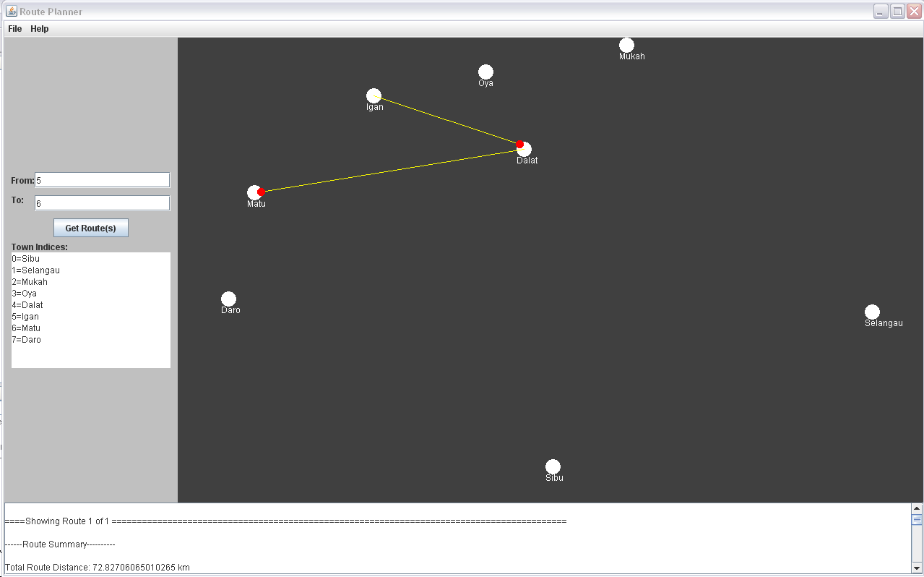

After adding a direct road between Igan and Matu, below is the result
